Git clone <repository>
Git clone https://github.com/Yoavtt/parcel_fabric_tasks.git
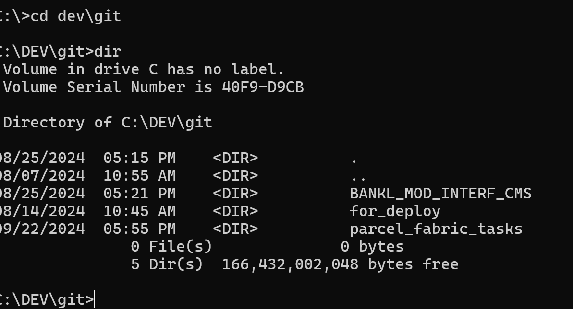

git branch
ברנצ'ים שקיימים במחשב המקומי
Git checkout <branch>
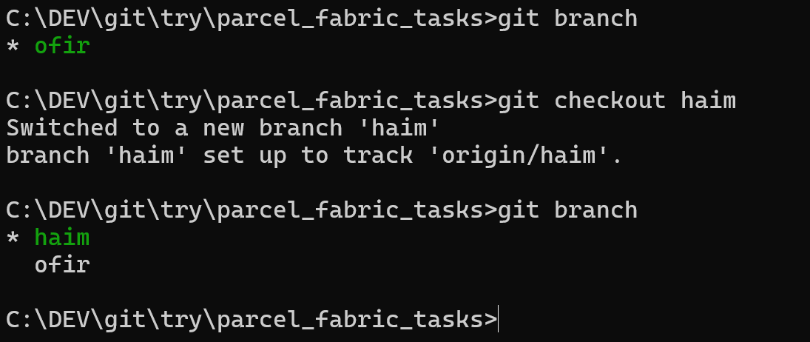
Git checkout -b <new_branch>
Git status
Git add . // staging all changes
Git add <filename> // staging only the <filename>
git commit -m "added prints to logger" // commits all staged files
git pull // recommended every beginning of work day
git push // pushes commit to github server

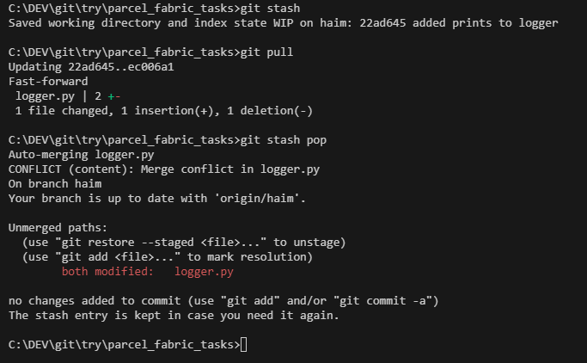
Example of creating branch, new commit and push a new branch
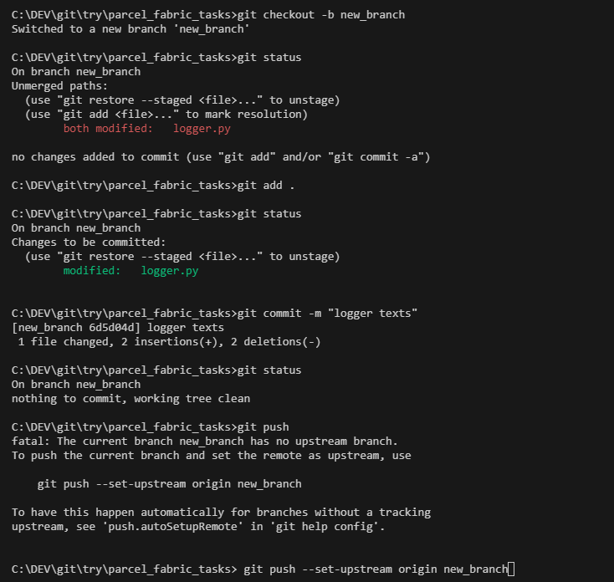
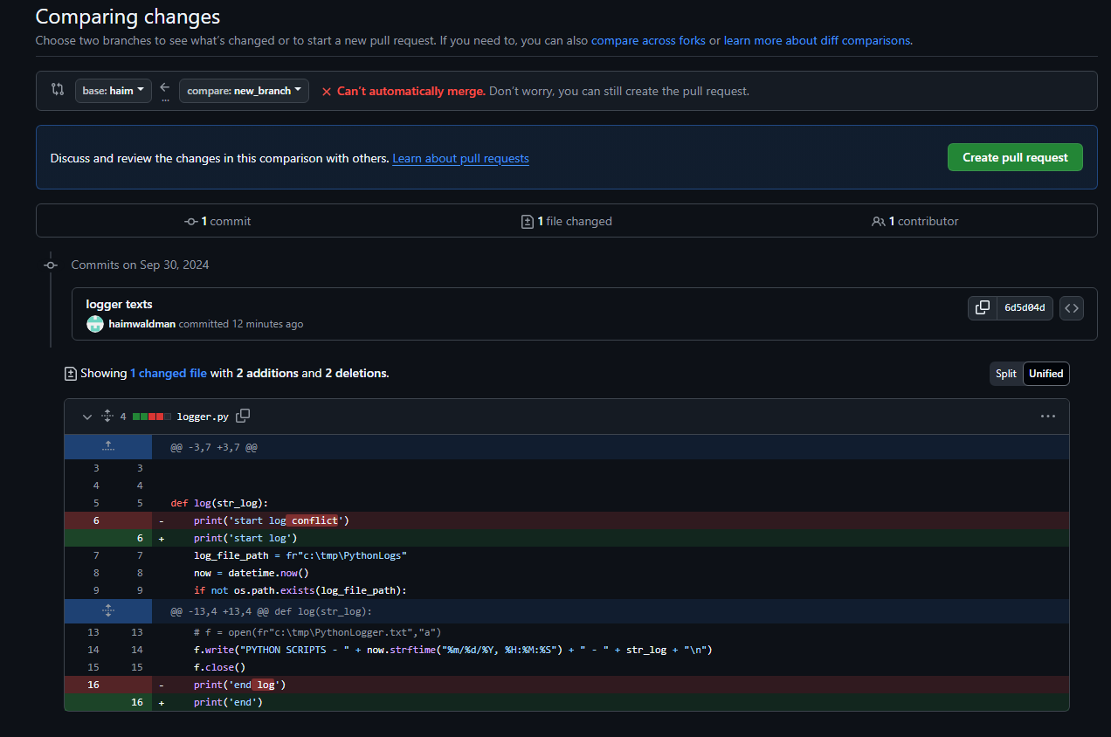
Pull request in Mapi doesn't require reviewer. It is recommended to merge with another person so the code will work.
Merge in github --- master <= <branch>

